CREATE TABLE users (

id INT PRIMARY KEY,

name VARCHAR(50)

);

CREATE TABLE books (

book_id INT PRIMARY KEY,

title VARCHAR(100),

author VARCHAR(100)

);

CREATE TABLE borrowings (

user_id INT,

book_id INT,

borrow_date DATE,

return_date DATE,

FOREIGN KEY (user_id) REFERENCES users(id),

FOREIGN KEY (book_id) REFERENCES books(book_id)

);



1. List all users and the books they have currently borrowed

SELECT u.name, b.title, b.author, bo.borrow_date

FROM users u

JOIN borrowings bo ON u.id = bo.user_id

JOIN books b ON bo.book_id = b.book_id

WHERE bo.return_date IS NULL;

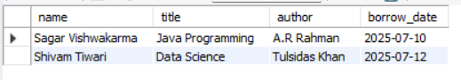

1. Find all Books by a specific author

SELECT title, author

FROM books

WHERE author = 'Han Zimmer';

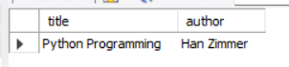

1. List Users who have borrowed more than 2 books

SELECT u.name , Count(bo.book_id) as borrow_count

From users u

LEft join borrowings bo on u.id = bo.user_id

group by u.id, u.name;

